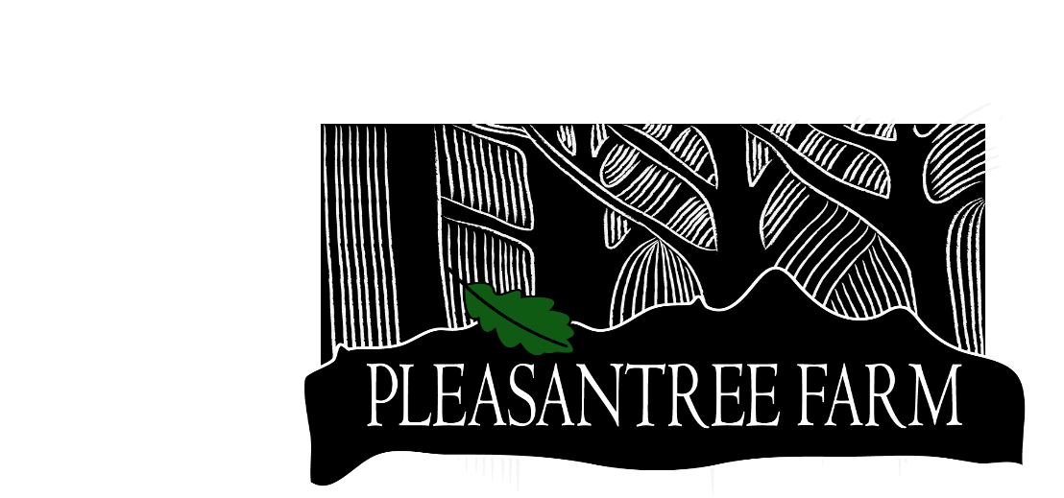

Clay & Megan Tallmadge
26490 CR P
P.O. Box 1363
Dolores, CO 81323
970-946-5763

BAGGED AND BURLAPPED TREES AND SHRUBS
Shade | Ornamental | Fruit/Nuts | Evergreens
Autumn Blaze Maple  Celebration Maple  Sienna Glen Maple  Mainstreet Maple  Pacific Sunset Maple  Big Tooth Maple  Sensation Maple  Tatarian Hotwings Maple Deborah Maple  Greenspire Linden  American Sentry Linden  New Horizon Elm  Northern Catalpa  Bur Oak  Kentucky Coffee Tree  Skyline Honeylocust Imperial Honeylocust  Laurel Leaf Willow  Oakleaf Mtn Ash  Showy Mtn Ash  Patmore Ash  Autumn Purple Ash  Autumn Splendor Buckeye  Narrowleaf Cottonwood  Robusta Cottonwood  Lanceleaf Cottonwood | Aspen  (single and clump)  Canada Red Choke Cherry  Springsnow Crabapple  Prairie fire Crabapple  Purple Prince Crabapple  Royalty Crabapple  Royal Raindrops Crabapple  Indian Magic Crabapple Purple Robe Locust  Autumn Blaze Pear  Cleveland Select Pear  Thornless Cockspur  Common Hawthorn  Golden Raintree  Newport Plum | Honeycrisp Apple  Gala Apple  Red Delicious Apple  Granny Smith Apple  Red McIntosh Apple  September Wonder Apple  State Fair Apple  Golden Delicious Apple  Zester Apple  Earligold Apple  Haralred Apple  Wenatchee Apricot  Moongold Apricot  Sungold Apricot  Montmorency Cherry  Evans Bali Cherry  Italian Prune  Stanley Prune  Summercrisp Pear  Carpathian Walnut | Colorado Blue Spruce  Ponderosa Pine  Austrian Black Pine  Scotch Pine  Southwest White Pine  Mugo Pine  Bristlecone Pine  White Fir  Douglas Fir  Siberian Larch  Shrubs  Common Purple Lilac  Miss Canada Lilac  Red Twig Dogwood  Native Chokecherry  Snow berry  Diablo Ninebark  Autumn B. Serviceberry  Artic Willow

*We have some “Park Grade” trees offered at a discounted price.
These trees have misshapen trunks or branching, bark damage and/or other cosmetic flaws.

